Model questions from Unit 1 and Unit 2
Short Questions
- Outline the need of Data Independence. Explain its types.
- Compare and contrast generalization and specialization with suitable example.
- List out the responsibilities of DBA in database system.
- Compare strong entity set and weak entity set with an example.
- Illustrate different types of attributes in ER model with suitable examples.
- Explain recursive relationship with an example.
- Write the fundamental differences between Network and hierarchical model.
- List any two steps for mapping an ER model into a relational model with suitable example.
- Define the following ER component: i) Weak and strong entity Set ii) Generalization and Specialization
- Explain the significance of descriptive attributes and NULL attributes in a database with suitable example.
- Describe the differences you find in ER model and relational model.
- Differentiate primary key and foreign key with suitable example. How can we identify the foreign key in a table.
- Differentiate between strong & weak entity set with suitable example?
- Write the role of database administrator.
- Discuss about the anomalies of hierarchical model and network model.
- Explain the difference between total and partial participation constraints.
- Illustrate various types of keys with suitable examples
- Mention the significance of descriptive attributes with proper examples
- Compare schema with instance, extension with intention
- Write key differences between: (i) Strong entity and weak entity
(ii) Composite and multi-valued attribute
- “All primary keys are candidate keys”-Justify it with an example.
- List out the features of extended ER Model in DBMS. Explain any one of the features with an example

Long Questions

- Describe data abstraction. Draw and explain the three-schema architecture of database system.
- Explain different record-based data models with suitable examples.
- Define DBMS. Discuss the advantages of database system over traditional file processing system.
- Design an ER diagram considering the following information.
A bank has many branches in a country. Each branch is identified with the help of branch name. Each branch of the bank has multiple customers. An employee of bank can be a manager or staff of that branch. Branch gives each customer a unique id to identify them. Customers can open two type of accounts i.e Savings account and Checking account. Branches of the bank provide Loan to the customers which are identified with the help of payment_id. Determine the different entities and relationships.
- State the concept of Data Integrity. Briefly explain the various Integrity constraints in database system.
- Discuss different types of keys in relational database with suitable examples.
- Discuss any two record based models with suitable examples. Mention the advantages of relational model over hierarchical model.
- (a) A university registrar’s office maintains data about the following entities: (a) courses, including number, title, credits, syllabus, and prerequisites; (b) course offerings, including course number, year, semester, section number, instructor(s), timings, and classroom; (c) students, including student-id, name, and program; and (d) instructors, including identification number, name, department, and title. Further, the enrollment of students in courses and grades awarded to students in each course they are enrolled for must be appropriately modeled. Construct an E-R diagram for the registrar’s office. Document all assumptions that you make about the mapping constraints.
- Convert the following ER-Model into an equivalent relational model of a hospital database system.
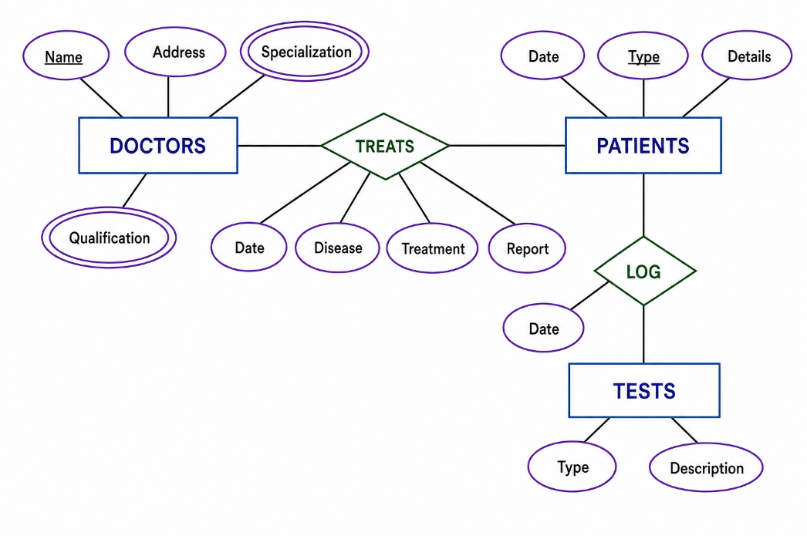
- Draw the ER diagram of a university database system.
- A hotel maintains information about its Hotels, Rooms, Guests, Employees, and Services. Each Hotel has Hotel_ID, Hotel_Name, Address, City, and Phone. Every hotel contains several rooms and employs many employees. Each Room has Room_No, Room_Type, Tariff, and Status. Every room belongs to exactly one hotel. Each Guest has Guest_ID, Name, Address, Phone, and Email. Guests reserve rooms. A guest may reserve several rooms over time, and a room may be reserved by many guests at different times. For every reservation, the hotel records Check_In_Date, Check_Out_Date, Number_of_Guests, and Total_Amount. Each Employee has Employee_ID, Name, Designation, and Salary. Employees work in only one hotel. The hotel also provides several Services such as Laundry, Wi-Fi, Restaurant, and Spa. Each service has Service_ID, Service_Name, and Charge. A room may receive many services, and one service can be provided to many rooms.

